**1.What are Artificial Neural Networks?**

* Neural networks, also known as artificial neural networks (ANNs) or simulated neural networks (SNNs), are a subset of [machine learning](https://www.ibm.com/cloud/learn/machine-learning) and are at the heart of [deep learning](https://www.ibm.com/cloud/learn/deep-learning) algorithms. Their name and structure are inspired by the human brain, mimicking the way that biological neurons signal to one another.
* Artificial neural networks (ANNs) are comprised of a node layers, containing an input layer, one or more hidden layers, and an output layer. Each node, or artificial neuron, connects to another and has an associated weight and threshold. If the output of any individual node is above the specified threshold value, that node is activated, sending data to the next layer of the network. Otherwise, no data is passed along to the next layer of the network.

**Q2.What are Layers in a Neural Network?**

* Artificial neural networks (ANNs) are comprised of a node layers, containing an input layer, one or more hidden layers, and an output layer
* A neural network can contains any number of neurons. These neurons are organized in the form of interconnected layers. The input layer can be used to represent the dataset and the initial conditions on the data.
* For example, suppose the input is a grayscale image, the output of every neuron in the input layer would be the intensity of every pixel of the image.
* This is the reason we don’t count the input layer as a part of the other layers in the neural network. When we refer to a 1-layer net, we actually refer to a simple network that contains one single layer, the output, and the additional input layer.
* We have previously seen that output layer can have one neuron. But there are cases where the output layer can have more than one neuron as well.

**Q3.What are Neurons in a Neural Network?**

* A layer consists of small individual units called neurons.A **neuron** in a neural network can be better understood with the help of biological neurons. An artificial neuron is similar to a biological neuron. It receives input from the other neurons, performs some processing, and produces an output.

Now let’s see an artificial neuron-

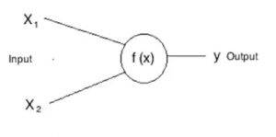

Here, **X1** and **X2** are inputs to the artificial neurons, **f(X)** represents the processing done on the inputs and **y**represents the output of the neuron.

**Q4. What is activation function in neural network.**

* Activation function decides, whether a neuron should be activated or not by calculating weighted sum and further adding bias with it. The purpose of the activation function is to **introduce non-linearity** into the output of a neuron.
* **Explanation :-** We know, neural network has neurons that work in correspondence of *weight, bias* and their respective activation function. In a neural network, we would update the weights and biases of the neurons on the basis of the error at the output. This process is known as *back-propagation*. Activation functions make the back-propagation possible since the gradients are supplied along with the error to update the weights and biases.

**Q5. what's the difference between biological neural network and artificial neural network.**

Biological Neural Network

* Our brain has a large network of interlinked neurons, which act as a highway for information to be transmitted from point A to point B.
* To send different kinds of information from A to B, the brain activates a different sets of neurons, and so essentially uses a different route to get from A to B. This is how a typical neuron 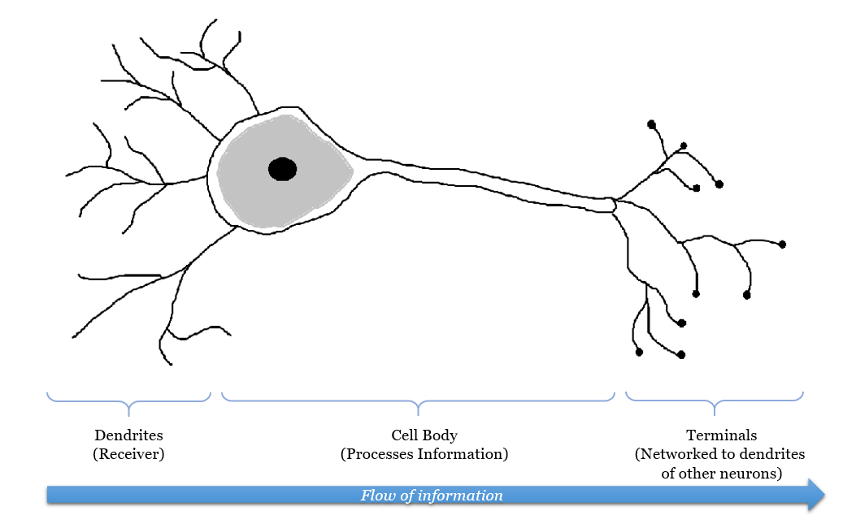

**Artificial neural network.**

* The ANN model is modelled after the biological neural network (and hence its namesake). Similarly, in the ANN model, we have an input node (in this example we give it a handwritten image of the number 6), and an output node, which is the digit that the program recognized.

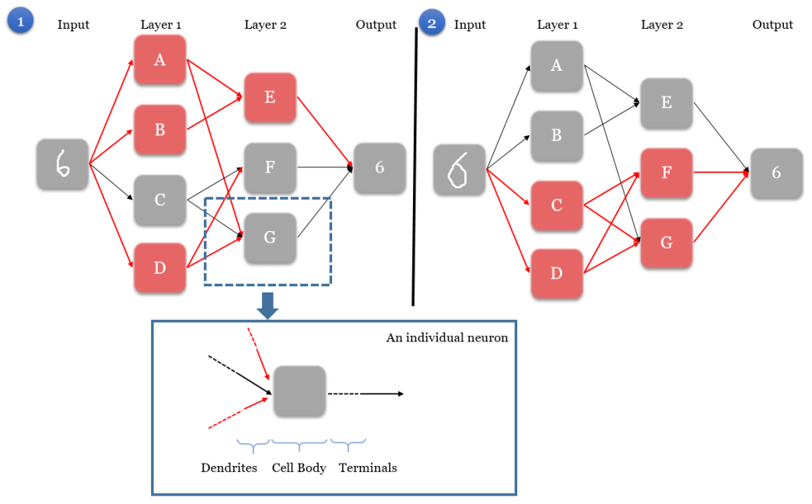

A simple Artificial Neural Network map, showing two scenarios with two different inputs but with the same output. Activated neurons along the path are shown in red.

* The main characteristics of an ANN is as such:
* **Step 1.** When the input node is given an image, it activates a unique set of neurons in the first layer, starting a chain reaction that would pave a unique path to the output node. In Scenario 1, neurons A, B, and D are activated in layer 1.
* **Step 2.** The activated neurons send signals to every connected neuron in the next layer. This directly affects which neurons are activated in the next layer. In Scenario 1, neuron A sends a signal to E and G, neuron B sends a signal to E, and neuron D sends a signal to F and G.
* **Step 3.** In the next layer, each neuron is governed by a rule on what combinations of received signals would activate the neuron (rules are trained when we give the ANN program training data, i.e. images of handwritten digits and the correct answer). In Scenario 1, neuron E is activated by the signals from A and B. However, for neuron F and G, their neurons’ rules tell them that they have not received the right signals to be activated, and hence they remains grey.
* **Step 4.** Steps 2-3 are repeated for all the remaining layers (it is possible for the model to have more than 2 layers), until we are left with the output node.
* **Step 5.** The output node deduces the correct digit based on signals received from neurons in the layer directly preceding it (layer 2). Each combination of activated neurons in layer 2 leads to one solution, though each solution can be represented by different combinations of activated neurons. In Scenarios 1 & 2, two images given to the input. Because the images are different, the network activates a different set of neurons to get from the input to the output. However, the output is still able to recognise that both images are “6”.